**Real-Time Based Solider Health Monitoring System**

**Using GPS and GSM**

S. Towseef Ahmed1, B. Muralidhar Reddy2, Y. NandaKrishna3, K. Raju4

1Assistant Professor, Department of ECE, G.Pullaiah College of Engineering and Technology, Kurnool – 518002, Andhra Pradesh, India

2,3,4UG Student, Department of ECE, G.Pullaiah College of Engineering and Technology, Kurnool – 518002, Andhra Pradesh, India

*Corresponding author. towseef.453@gmail.com

**Abstract:**

In today's world, the security of the country depends on the enemy's war, so the security of the army is also important. The country's armed forces have three services: army, army and army. Considering the safety of soldiers, many tools can check the health and ammunition of soldiers. To overcome security issues, we developed this project to include temperature, heart rate sensors, etc. that can monitor soldiers' health when necessary. We developed it using a network of wireless body area sensors. Using GPS, we can track the exact location of soldiers when necessary. These devices are added to guns, weapons, and soldiers; For example, the Israeli Army is exploring the possibility of having GPS devices on soldiers' shirts and uniforms so that leaders in the region can instantly track the army's movements. Fast transmission, short-range, and effective military-to-military wireless communications will be needed to transmit information related to surveillance-related situational awareness, decision-making, and data protection during special investigations and other operations. By using all these tools, we are trying to use simple defense systems for the army with low-cost, light, easy-to-carry, and sensitive equipment. In today's world, war is an important part of every country's security. The army plays an important and important role. In our study, we revealed the idea of ​​tracking soldiers and ensuring their health during war, which enables soldiers to prepare war strategies. The base station can learn the location of the soldiers using the location sent by the GPS modem.

**Index terms:** Arduino Nano, temperature sensor, GSM, GPS, LCD, buzzer, pulse rate sensor, temperature sensor, Arduino IDE, onboard C

**Introduction:**

The main objective of this mission is to find the exact location of injured soldiers on the battlefield. GSM-based military health and location tracking system stores the location of the army based on latitude and longitude [1,2,3]. The LCD is connected to the Arduino to capture the received data before sending it via GSM [4]. The military must cooperate with medical monitoring, continuous GPS (Global Positioning System), and data exchange to send and receive information to control facilities [5,6,7]. It may be needed not only for soldiers to communicate remotely with the control center, but also for the control room of other soldiers. In addition to national security, the military also needs to ensure their health by ensuring the military's ability to perform well, and the organization must maintain checks on the authorities who manage military medicine [8, 9]. To meet this need, bio-therapeutic sensors, and analysis tools are integrated into the operator in this paper. The composite material should be lightweight and provide the desired results without requiring too much energy. One of the main problems in the army is the unpreparedness of officers in talking to commanders[10,11]. More importantly, the military's strategic approach plays a key role in careful planning and coordination. Therefore, operational plans focus on monitoring combat zones, which will be useful for the station control room to know the officer's watchful area and guide them if necessary yes. The control center uses GPS to locate the battle location [12,13]. When a soldier falls on the battlefield, the base station needs to point him in the right direction. This article will be useful for soldiers participating in special events or missions. This jacket can detect heart rate sensors, temperature and humidity sensors, vibration sensors, explosives, etc. It is equipped with a good electronic rear including [14,15,16]. These are deployed in the military for full portability. The framework will use remote connections to access the stations' servers. Data collected from the base station can be used for further predictions [17,18]. This allows the administration to take into account the conditions of the mandate. The security of the country is monitored and maintained by the Land, Navy, and Air Forces. Soldiers who sacrifice their lives for their country perform the most important and important duty. There are many concerns about the safety of soldiers. Soldiers who enter enemy lines often die due to lack of communication, and the military base station needs to know where each soldier is and what he is doing [19,20]. India lost a large number of soldiers in the war due to a lack of health support and communication between the soldiers on the battlefield and the leaders of their son's fat base station.

**Literature Review:**

* During war and military reconnaissance, soldiers are injured and sometimes even destroyed [25,26]. To locate Soldiers and provide health care, military base stations require GPS equipment to locate Soldiers, WBASNs to notify Soldiers about health, and wireless transceivers to transmit data wirelessly.
* Shruti Nikam, SupriyaPatil, Prajkta Power, V.S. Bendre presented an idea for the safety of soldiers. Tracking was used during World War II when the military found it useful in navigation, positioning, targeting, and ship control. It has been an important mission since World War II[27,28]. The system is reliable, energy-efficient, and can be used for remote military health monitoring and location tracking. He managed to send the army, which was now unknown and successful. The military control room monitors soldiers' heart rate, body temperature, etc. using a network of body sensors. Allows you to monitor health parameters. Use GSM to continuously measure and wirelessly send soldiers without limits.

**Existing system:**

The current system tracks the health status of soldiers and referrals are used for SMS communication.

**Proposed system:**

The application process includes a microcontroller, temperature sensor, heart rate sensor, buzzer, LCD, GPS, and GSM modem. The microcontroller controlled all signals and activities in the military room.

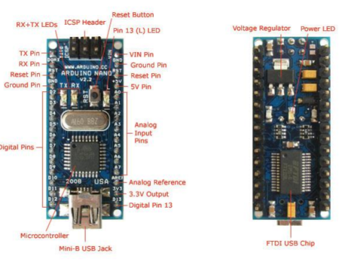**Hardware description:**

**Arduino Nano:**

Arduino Nano is a small, complete breadboard board based on ATmega328 (Arduino Nano 3.0) or ATmega168 (Arduino Nano 2. x). It has almost the same functionality as Arduino Duemilanove but in a different package. It just doesn't have a DC power supply and can use a Mini-B USB cable instead of a standard cable. Designed and manufactured by Nano Gravitech. **Fig.2. Arduino Nano pinout**

The Arduino software includes a Wire library that easily uses the I2C bus;

**Liquid crystal display (LCD):**

An LCD (liquid crystal display) display is an electronic device with many uses. 16x2 LCD screen is a very simple model that is frequently used in many devices and circuits. **Fig.3. LCD**

**GPS NEO6M:**

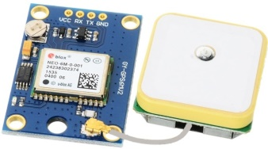GPS stands for Global Positioning System, where anyone can get location information anywhere in the world at any time. First, a time signal is sent to a specific location by the GPS satellite. The time difference between the GPS time and the time point at which the GPS receiver receives the time signal is then calculated to determine the distance from the receiver to the satellite. The same process will be done for the other three satellites. **Fig.4. GPS NEO 6M**

**GSM Module SIM 800L:**

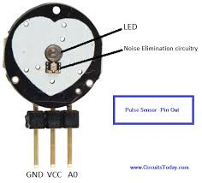 The Sim800L module is a low-cost, small GSM module based on Simcom's SIM800L chipset. This low cost is perfect for starting your next IoT project[48]. You can almost make your phone with this mod. The main disadvantage of this module is that it operates on 3.7 to 4.2 volts, so you cannot power it directly from Arduino or Raspberry Pi. Additionally, sim800L GSM and GPRS modules require up to 2 amps of current, so design your power supply accordingly. **Fig.5.SIM800L**

**Pulse sensor:**

Connect the heart rate sensor to Arduino. The pulse sensor has three pins. Connect the 5V and ground pins of the pulse sensor to the 5V and ground pin of the Arduino and the signal pin to the A0 pin of the Arduino. A simple heart rate sensor consists of a light-emitting diode and a detector, such as a light resistor or photodiode.

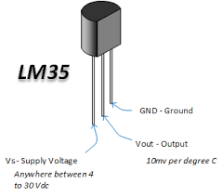**LM-35 Temperature Sensor:**

LM35 is a temperature sensor that can be used to measure temperature by comparing the fire Exit temperature in °C. It can measure more temperatures than the thermistor. This sensor produces a higher output than the thermocouple and does not require increasing the output voltage. The scale factor is .01V/°C. **Fig.7 . LM35 Temperature sensor**

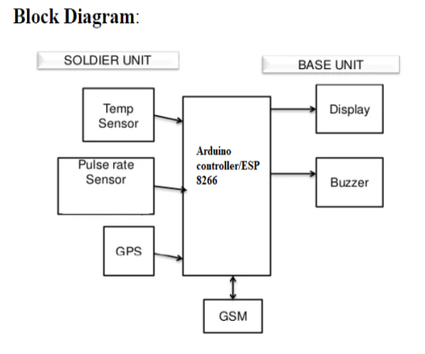**Methodology:**

**Working process:**

The main objective of this mission is to find the exact location of injured soldiers on the battlefield. GSM-based military health and location tracking system stores the location of the army based on latitude and longitude. This data is fed to the Arduino, which is interfaced with the GSM modem. Arduino collects exact location information from GPS and sends SMS to the relevant organization via GSM modem. **Fig.1. Proposed system architecture**

The LCD is connected to the Arduino to capture the received data before sending it via GSM. This project is very useful for tracking soldiers at the military base station.

**Result and Discussion:**

**Fig.8. GSM-based soldier health monitoring in real time**

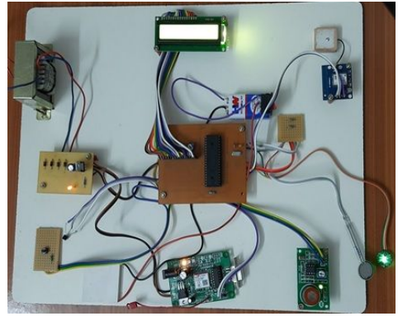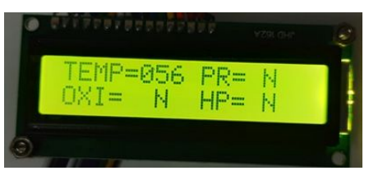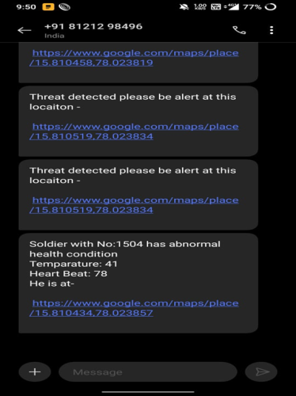

**Advantages and applications:**

• No need to go on the field.

• Higher reliability.

• Cost effective.

• Fast and efficient

There are several ways in which the soldier can communicate with the base station. eg- Bluetooth, Zigbee modules, Wi-Fi, GSM, etc.

**Conclusion:**

The Army's Healthcare and Location Tracking GPS program is a key safety and security feature that combines electronic and wireless automation. We infer that the above system is used to monitor the physical health of soldiers using the heart rate sensor, temperature sensor, pressure sensor, and oxygen sensor. This method is also useful for soldiers in war because if they think they are in a critical situation, they can ask for help from the base station by pressing the button on the base station. Our scheme also sends information about the location and intent of the SMS to the base station. Our plan will provide greater security to our soldiers by connecting the gas detector to the appropriate sensor station. Interconnecting a camera to the controller may also be used to improve this process. Once the above process is completed, it will help determine the health of soldiers by measuring heart rate and body temperature. It will also help in tracking its location using a GPS modem and through a GSM modem it will be able to send all the data to the base station for further processing.

**References:**

[1] Hock Beng Lim, Di Ma, Bang Wang, Zbigniew Kalbarczyk, Ravishankar K. Iyer, Kenneth L. Watkin (2010) “A Soldier Health Monitoring System for Military Applications” International Conference on Body Sensor Networks, pp: (246-249).

[2] William Walker, A. L. Praveen Aroul, Dinesh Bhatia (2009) “Mobile Health Monitoring Systems” 31st Annual International Conference of the IEEE EMBS, Minneapolis, Minnesota, USA, pp: (5199-5202).

[3] M. Pranav Sailesh, C. Vimal Kumar, B. Cecil, B. M. Mangal Deep, P. Sivraj (2014) “Smart Soldier Assistance using WSN” International Conference on Embedded Systems - (ICES 2014), IEEE, pp: (244-249).

[4] P.S. Kurhe, S.S. Agrawal (2013) “Real Time Tracking and Health Monitoring System of Remote Soldier Using ARM 7”, International Journal of Engineering Trends and Technology, 4(3), pp: (311-315).

[5] Shruti Nikam, Supriya Patil, Prajkta Powar, V. S. Bendre (2013) “GPS Based Soldier Tracking and Health Indication System” International Journal of Advanced Research in Electrical, Electronics and Instrumentation Engineering, 2(3), pp: (1082-1088).

[6] Prof. Pravin Wararkar, Sawan Mahajan, Ashu Mahajan, Arijit Banerjee, Anchal Madankar, Ashish Sontakke (2013) “Soldier Tracking and Health Monitoring System” The International Journal of Computer Science & Applications, 2(02), pp: (81-86).

[7] Govindaraj A., Dr. S. Sindhuja Banu (2013) “GPS Based Soldier Tracking and Health Indication System with Environmental Analysis”, International Journal of Enhanced Research in Science Technology & Engineering, 2(12), pp: (46-52).

[8] Palve Pramod, “GPS Based Advanced Soldier Tracking With Emergency Messages & Communication System” (2014) International Journal of Advance Research in Computer Science and Management Studies, 2(6), pp: (25-32).

[9] Mr. Rajdeep Limbu, Prof. V. V. Kale (2014) “GPS Based Soldier Tracking and Health Monitoring System” International Journal for Technological Research in Engineering, 1(12), pp: (1485- 1488).

[10] Simon L. Cotton and William G. Scanlon ―Millimeter - wave Soldier –to soldier communications for covert battlefield operations Defence science and technology laboratory, IEEE communication Magzin October 2009.

[11] Hock Beng Lim “A Soldier Health Monitoring System for Military Applications‖ 2010 International Conference on Body Sensor Networks (BSN).

[12] JouniRantakoko,JoakimRydell and peter Stromback,‖Accurate and Realiable soldier and first responder Poasitioning :Multisensor System and co-operative localization‖April-2011.

[13] Vincent Pereira, AudreyGiremus,andericgrivel ―Modeling of the multipath environment using copulas For particle filtering based GPSnavigation‖ June-2012

[14] M.V.N.R. Pavan Kumar1, Ghadge Rasika Vijay2, PatilVidya Adhikrao3, Bobade Sonali Vijaykumar4 Department of Electronics and Telecommunication Engineering 1,2,3,4, LNBCIET, Satara-415020 1,2,3,4Health Monitoring and Tracking of Soldier Using GPS.

[15] Arya V Nair, Rani Raju, Tinsa Elsa Thomas and Vidya R Nair, “IoT Based Soldier Monitoring System”, Pramana Research Journal, Volume No:9, Issue:5, pp: 157-165,2019.

[16] Brijesh Iyer and Niket Patil, “IoT enabled tracking and monitoring sensor for military applications”, International Journal of Systems Assurance Engineering and Management, SPRINGER, July-2018.

[17] D. Poornakumar, R. Periyanayaki, M. R. Pradheepa, N. Prakashkumar, and S. Nandhini, “Soldiers Navigation and Health Monitoring System using GPS and GSM”, International Journal of Research in Engineering Science and Management, Volume No: 3, Issue:4,pp:115-158, April-2020.

[18] Deepa J, Ranjini, Sharanya Raj and Dr.Parameshachari B D, “Soldier Health Positioning Tracking System Using GPS and GSM Modem”, International Journal of Engineering Research& Technology (IJERT),pp:1-6,2018.

[19] Dineshwar Jaiswar and Sanjana S. Repal, “Real-Time Tracking and Health Monitoring of Soldier using ZigBee Technology”, International Journal of Innovative Research in Science, Engineering, and Technology: a Survey, Volume No:4, Issue:7, pp: 5560-5574, July-2015.

[20] E. J. Shanko and M. G. Papoutsidakis, “Real-time health monitoring and wireless transmission: A μController application to improve human medical needs”, 2013 E-Health and Bioengineering Conference (EHB), Isai,pp:242-249,2013.